Делаем вертолет из бутылки с детьми. Интересно и весело 🚁

[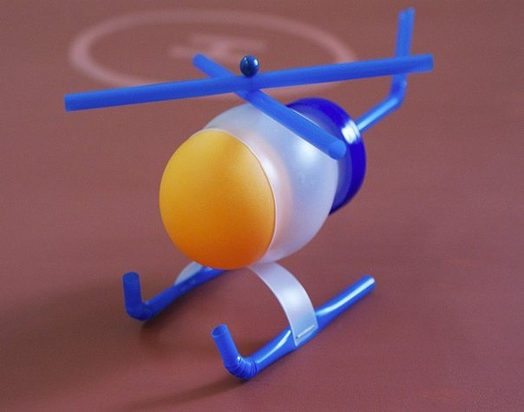](http://ok.ru/dk?cmd=PopLayerPhoto&st.layer.cmd=PopLayerPhotoOuter&st.layer.type=GROUP&st.layer.revNav=off&st.layer.limitedUi=false&st.layer.sphotoIds=814805814845%3B814805815101%3B814805815357%3B814805815613%3B814805815869%3B814805816125%3B814805816381%3B814805816637&st.layer.showNav=on&st.layer.photoAlbumId=57619109773373&st.layer.epm=off&st.layer.photoId=814805814845&st.layer.opl=off&st.layer.navStartPhotoId=814805814845&st.layer.sbd=off&st.cmd=userMain&st._aid=GroupTopicLayer_openPhotoLayer)

[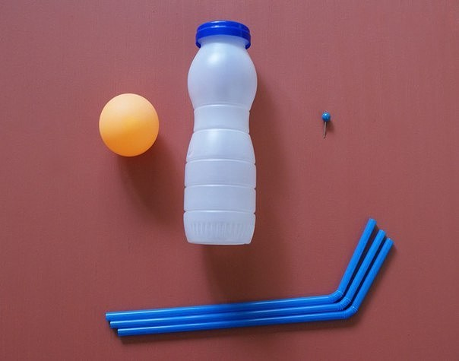](http://ok.ru/dk?cmd=PopLayerPhoto&st.layer.cmd=PopLayerPhotoOuter&st.layer.type=GROUP&st.layer.revNav=off&st.layer.limitedUi=false&st.layer.sphotoIds=814805814845%3B814805815101%3B814805815357%3B814805815613%3B814805815869%3B814805816125%3B814805816381%3B814805816637&st.layer.showNav=on&st.layer.photoAlbumId=57619109773373&st.layer.epm=off&st.layer.photoId=814805815101&st.layer.opl=off&st.layer.navStartPhotoId=814805815101&st.layer.sbd=off&st.cmd=userMain&st._aid=GroupTopicLayer_openPhotoLayer)

[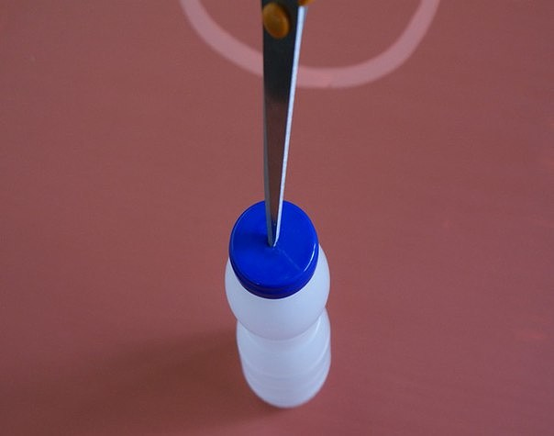](http://ok.ru/dk?cmd=PopLayerPhoto&st.layer.cmd=PopLayerPhotoOuter&st.layer.type=GROUP&st.layer.revNav=off&st.layer.limitedUi=false&st.layer.sphotoIds=814805814845%3B814805815101%3B814805815357%3B814805815613%3B814805815869%3B814805816125%3B814805816381%3B814805816637&st.layer.showNav=on&st.layer.photoAlbumId=57619109773373&st.layer.epm=off&st.layer.photoId=814805815357&st.layer.opl=off&st.layer.navStartPhotoId=814805815357&st.layer.sbd=off&st.cmd=userMain&st._aid=GroupTopicLayer_openPhotoLayer)

[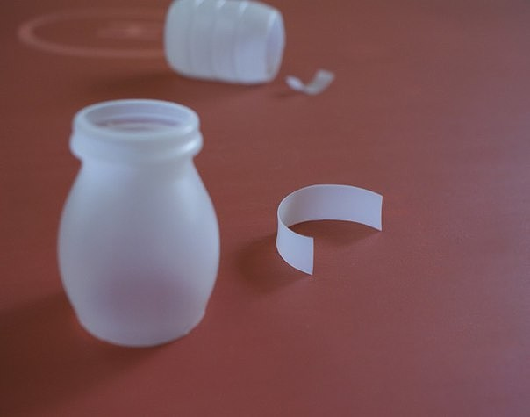](http://ok.ru/dk?cmd=PopLayerPhoto&st.layer.cmd=PopLayerPhotoOuter&st.layer.type=GROUP&st.layer.revNav=off&st.layer.limitedUi=false&st.layer.sphotoIds=814805814845%3B814805815101%3B814805815357%3B814805815613%3B814805815869%3B814805816125%3B814805816381%3B814805816637&st.layer.showNav=on&st.layer.photoAlbumId=57619109773373&st.layer.epm=off&st.layer.photoId=814805815613&st.layer.opl=off&st.layer.navStartPhotoId=814805815613&st.layer.sbd=off&st.cmd=userMain&st._aid=GroupTopicLayer_openPhotoLayer)

[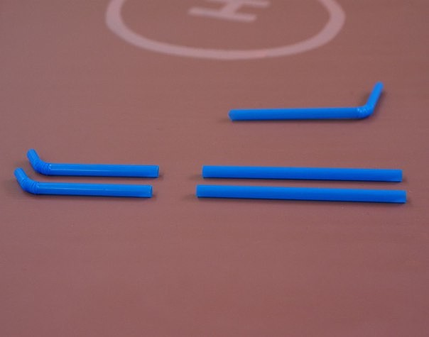](http://ok.ru/dk?cmd=PopLayerPhoto&st.layer.cmd=PopLayerPhotoOuter&st.layer.type=GROUP&st.layer.revNav=off&st.layer.limitedUi=false&st.layer.sphotoIds=814805814845%3B814805815101%3B814805815357%3B814805815613%3B814805815869%3B814805816125%3B814805816381%3B814805816637&st.layer.showNav=on&st.layer.photoAlbumId=57619109773373&st.layer.epm=off&st.layer.photoId=814805815869&st.layer.opl=off&st.layer.navStartPhotoId=814805815869&st.layer.sbd=off&st.cmd=userMain&st._aid=GroupTopicLayer_openPhotoLayer)

[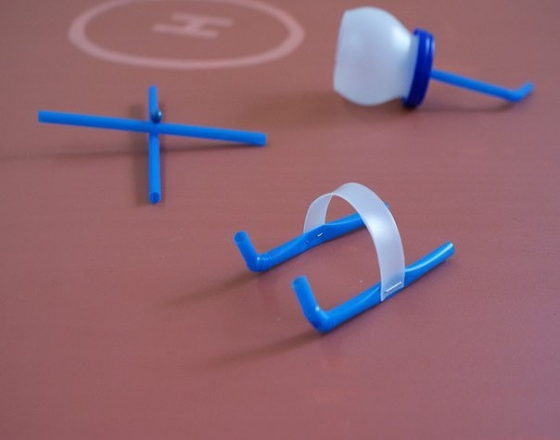](http://ok.ru/dk?cmd=PopLayerPhoto&st.layer.cmd=PopLayerPhotoOuter&st.layer.type=GROUP&st.layer.revNav=off&st.layer.limitedUi=false&st.layer.sphotoIds=814805814845%3B814805815101%3B814805815357%3B814805815613%3B814805815869%3B814805816125%3B814805816381%3B814805816637&st.layer.showNav=on&st.layer.photoAlbumId=57619109773373&st.layer.epm=off&st.layer.photoId=814805816125&st.layer.opl=off&st.layer.navStartPhotoId=814805816125&st.layer.sbd=off&st.cmd=userMain&st._aid=GroupTopicLayer_openPhotoLayer)

[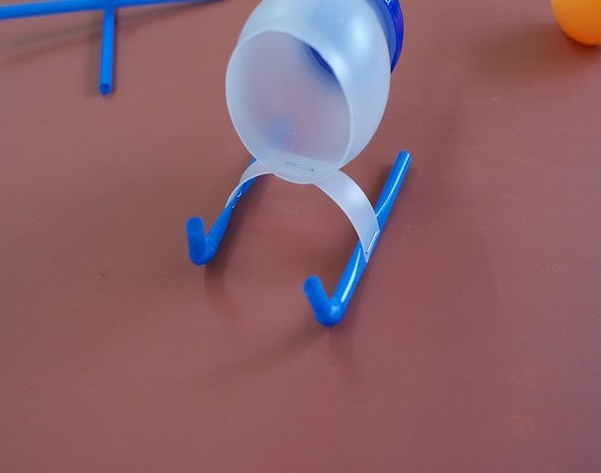](http://ok.ru/dk?cmd=PopLayerPhoto&st.layer.cmd=PopLayerPhotoOuter&st.layer.type=GROUP&st.layer.revNav=off&st.layer.limitedUi=false&st.layer.sphotoIds=814805814845%3B814805815101%3B814805815357%3B814805815613%3B814805815869%3B814805816125%3B814805816381%3B814805816637&st.layer.showNav=on&st.layer.photoAlbumId=57619109773373&st.layer.epm=off&st.layer.photoId=814805816381&st.layer.opl=off&st.layer.navStartPhotoId=814805816381&st.layer.sbd=off&st.cmd=userMain&st._aid=GroupTopicLayer_openPhotoLayer)

[](http://ok.ru/dk?cmd=PopLayerPhoto&st.layer.cmd=PopLayerPhotoOuter&st.layer.type=GROUP&st.layer.revNav=off&st.layer.limitedUi=false&st.layer.sphotoIds=814805814845%3B814805815101%3B814805815357%3B814805815613%3B814805815869%3B814805816125%3B814805816381%3B814805816637&st.layer.showNav=on&st.layer.photoAlbumId=57619109773373&st.layer.epm=off&st.layer.photoId=814805816637&st.layer.opl=off&st.layer.navStartPhotoId=814805816637&st.layer.sbd=off&st.cmd=userMain&st._aid=GroupTopicLayer_openPhotoLayer)