ПОТЕШКИ НА ВСЕ СЛУЧАИ ЖИЗНИ!

[](http://ok.ru/dk?cmd=PopLayerPhoto&st.layer.cmd=PopLayerPhotoOuter&st.layer.type=GROUP&st.layer.revNav=off&st.layer.limitedUi=false&st.layer.sphotoIds=815343472761%3B815343473017%3B815343473273%3B815343473529%3B815343473785%3B815343474041%3B815343474297%3B815343474553%3B815343474809&st.layer.showNav=on&st.layer.photoAlbumId=52205150142585&st.layer.epm=off&st.layer.photoId=815343472761&st.layer.opl=off&st.layer.navStartPhotoId=815343472761&st.layer.sbd=off&st.cmd=userMain&st._aid=GroupTopicLayer_openPhotoLayer)

[](http://ok.ru/dk?cmd=PopLayerPhoto&st.layer.cmd=PopLayerPhotoOuter&st.layer.type=GROUP&st.layer.revNav=off&st.layer.limitedUi=false&st.layer.sphotoIds=815343472761%3B815343473017%3B815343473273%3B815343473529%3B815343473785%3B815343474041%3B815343474297%3B815343474553%3B815343474809&st.layer.showNav=on&st.layer.photoAlbumId=52205150142585&st.layer.epm=off&st.layer.photoId=815343473017&st.layer.opl=off&st.layer.navStartPhotoId=815343473017&st.layer.sbd=off&st.cmd=userMain&st._aid=GroupTopicLayer_openPhotoLayer)

[](http://ok.ru/dk?cmd=PopLayerPhoto&st.layer.cmd=PopLayerPhotoOuter&st.layer.type=GROUP&st.layer.revNav=off&st.layer.limitedUi=false&st.layer.sphotoIds=815343472761%3B815343473017%3B815343473273%3B815343473529%3B815343473785%3B815343474041%3B815343474297%3B815343474553%3B815343474809&st.layer.showNav=on&st.layer.photoAlbumId=52205150142585&st.layer.epm=off&st.layer.photoId=815343473273&st.layer.opl=off&st.layer.navStartPhotoId=815343473273&st.layer.sbd=off&st.cmd=userMain&st._aid=GroupTopicLayer_openPhotoLayer)

[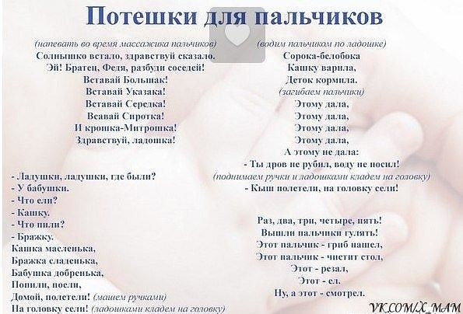](http://ok.ru/dk?cmd=PopLayerPhoto&st.layer.cmd=PopLayerPhotoOuter&st.layer.type=GROUP&st.layer.revNav=off&st.layer.limitedUi=false&st.layer.sphotoIds=815343472761%3B815343473017%3B815343473273%3B815343473529%3B815343473785%3B815343474041%3B815343474297%3B815343474553%3B815343474809&st.layer.showNav=on&st.layer.photoAlbumId=52205150142585&st.layer.epm=off&st.layer.photoId=815343473529&st.layer.opl=off&st.layer.navStartPhotoId=815343473529&st.layer.sbd=off&st.cmd=userMain&st._aid=GroupTopicLayer_openPhotoLayer)

[](http://ok.ru/dk?cmd=PopLayerPhoto&st.layer.cmd=PopLayerPhotoOuter&st.layer.type=GROUP&st.layer.revNav=off&st.layer.limitedUi=false&st.layer.sphotoIds=815343472761%3B815343473017%3B815343473273%3B815343473529%3B815343473785%3B815343474041%3B815343474297%3B815343474553%3B815343474809&st.layer.showNav=on&st.layer.photoAlbumId=52205150142585&st.layer.epm=off&st.layer.photoId=815343473785&st.layer.opl=off&st.layer.navStartPhotoId=815343473785&st.layer.sbd=off&st.cmd=userMain&st._aid=GroupTopicLayer_openPhotoLayer)

[](http://ok.ru/dk?cmd=PopLayerPhoto&st.layer.cmd=PopLayerPhotoOuter&st.layer.type=GROUP&st.layer.revNav=off&st.layer.limitedUi=false&st.layer.sphotoIds=815343472761%3B815343473017%3B815343473273%3B815343473529%3B815343473785%3B815343474041%3B815343474297%3B815343474553%3B815343474809&st.layer.showNav=on&st.layer.photoAlbumId=52205150142585&st.layer.epm=off&st.layer.photoId=815343474041&st.layer.opl=off&st.layer.navStartPhotoId=815343474041&st.layer.sbd=off&st.cmd=userMain&st._aid=GroupTopicLayer_openPhotoLayer)

[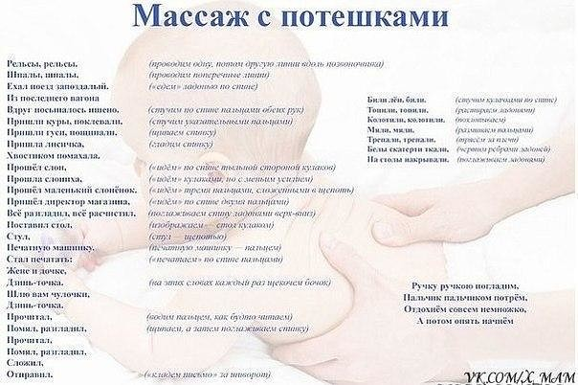](http://ok.ru/dk?cmd=PopLayerPhoto&st.layer.cmd=PopLayerPhotoOuter&st.layer.type=GROUP&st.layer.revNav=off&st.layer.limitedUi=false&st.layer.sphotoIds=815343472761%3B815343473017%3B815343473273%3B815343473529%3B815343473785%3B815343474041%3B815343474297%3B815343474553%3B815343474809&st.layer.showNav=on&st.layer.photoAlbumId=52205150142585&st.layer.epm=off&st.layer.photoId=815343474297&st.layer.opl=off&st.layer.navStartPhotoId=815343474297&st.layer.sbd=off&st.cmd=userMain&st._aid=GroupTopicLayer_openPhotoLayer)

[](http://ok.ru/dk?cmd=PopLayerPhoto&st.layer.cmd=PopLayerPhotoOuter&st.layer.type=GROUP&st.layer.revNav=off&st.layer.limitedUi=false&st.layer.sphotoIds=815343472761%3B815343473017%3B815343473273%3B815343473529%3B815343473785%3B815343474041%3B815343474297%3B815343474553%3B815343474809&st.layer.showNav=on&st.layer.photoAlbumId=52205150142585&st.layer.epm=off&st.layer.photoId=815343474553&st.layer.opl=off&st.layer.navStartPhotoId=815343474553&st.layer.sbd=off&st.cmd=userMain&st._aid=GroupTopicLayer_openPhotoLayer)

[](http://ok.ru/dk?cmd=PopLayerPhoto&st.layer.cmd=PopLayerPhotoOuter&st.layer.type=GROUP&st.layer.revNav=off&st.layer.limitedUi=false&st.layer.sphotoIds=815343472761%3B815343473017%3B815343473273%3B815343473529%3B815343473785%3B815343474041%3B815343474297%3B815343474553%3B815343474809&st.layer.showNav=on&st.layer.photoAlbumId=52205150142585&st.layer.epm=off&st.layer.photoId=815343474809&st.layer.opl=off&st.layer.navStartPhotoId=815343474809&st.layer.sbd=off&st.cmd=userMain&st._aid=GroupTopicLayer_openPhotoLayer)