Снежинка- декор

[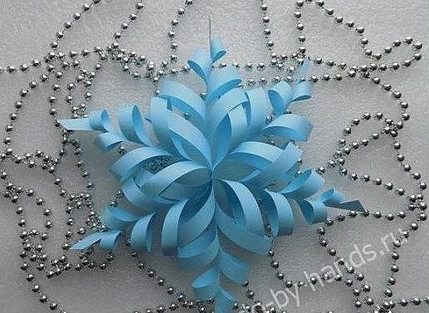](https://ok.ru/dk?cmd=PopLayerPhoto&st.layer.cmd=PopLayerPhotoOuter&st.layer.type=GROUP&st.layer.revNav=off&st.layer.limitedUi=false&st.layer.sphotoIds=849496514051%3B849496514819%3B849496516099%3B849496516355%3B849496517123%3B849496518659%3B849496521731%3B849496522755%3B849496531203&st.layer.showNav=on&st.layer.photoAlbumId=54623410388995&st.layer.epm=off&st.layer.photoId=849496514819&st.layer.opl=off&st.layer.navStartPhotoId=849496514819&st.layer.sbd=off&st.cmd=userMain&st._aid=GroupTopicLayer_openPhotoLayer)

[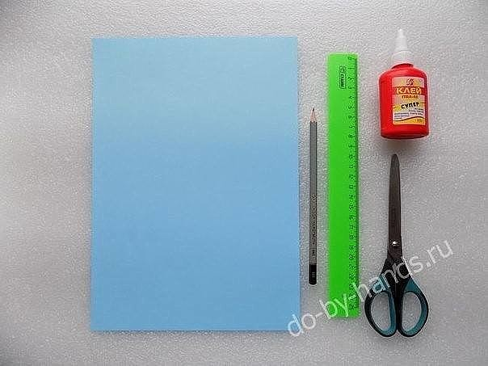](https://ok.ru/dk?cmd=PopLayerPhoto&st.layer.cmd=PopLayerPhotoOuter&st.layer.type=GROUP&st.layer.revNav=off&st.layer.limitedUi=false&st.layer.sphotoIds=849496514051%3B849496514819%3B849496516099%3B849496516355%3B849496517123%3B849496518659%3B849496521731%3B849496522755%3B849496531203&st.layer.showNav=on&st.layer.photoAlbumId=54623410388995&st.layer.epm=off&st.layer.photoId=849496516099&st.layer.opl=off&st.layer.navStartPhotoId=849496516099&st.layer.sbd=off&st.cmd=userMain&st._aid=GroupTopicLayer_openPhotoLayer)

[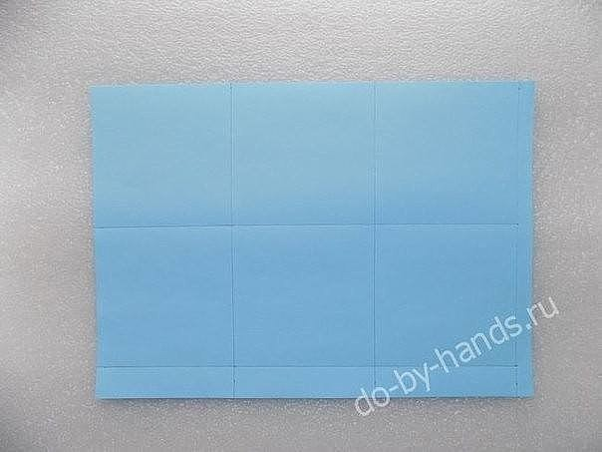](https://ok.ru/dk?cmd=PopLayerPhoto&st.layer.cmd=PopLayerPhotoOuter&st.layer.type=GROUP&st.layer.revNav=off&st.layer.limitedUi=false&st.layer.sphotoIds=849496514051%3B849496514819%3B849496516099%3B849496516355%3B849496517123%3B849496518659%3B849496521731%3B849496522755%3B849496531203&st.layer.showNav=on&st.layer.photoAlbumId=54623410388995&st.layer.epm=off&st.layer.photoId=849496516355&st.layer.opl=off&st.layer.navStartPhotoId=849496516355&st.layer.sbd=off&st.cmd=userMain&st._aid=GroupTopicLayer_openPhotoLayer)

[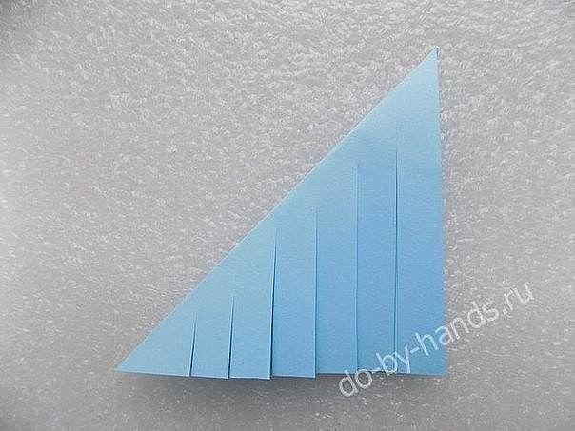](https://ok.ru/dk?cmd=PopLayerPhoto&st.layer.cmd=PopLayerPhotoOuter&st.layer.type=GROUP&st.layer.revNav=off&st.layer.limitedUi=false&st.layer.sphotoIds=849496514051%3B849496514819%3B849496516099%3B849496516355%3B849496517123%3B849496518659%3B849496521731%3B849496522755%3B849496531203&st.layer.showNav=on&st.layer.photoAlbumId=54623410388995&st.layer.epm=off&st.layer.photoId=849496517123&st.layer.opl=off&st.layer.navStartPhotoId=849496517123&st.layer.sbd=off&st.cmd=userMain&st._aid=GroupTopicLayer_openPhotoLayer)

[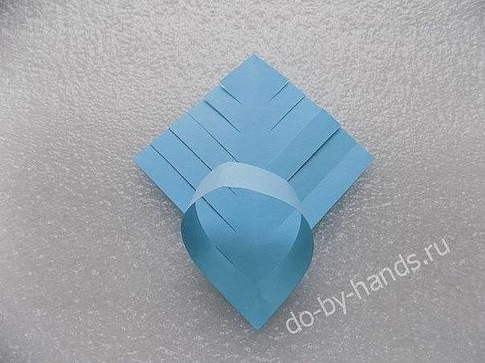](https://ok.ru/dk?cmd=PopLayerPhoto&st.layer.cmd=PopLayerPhotoOuter&st.layer.type=GROUP&st.layer.revNav=off&st.layer.limitedUi=false&st.layer.sphotoIds=849496514051%3B849496514819%3B849496516099%3B849496516355%3B849496517123%3B849496518659%3B849496521731%3B849496522755%3B849496531203&st.layer.showNav=on&st.layer.photoAlbumId=54623410388995&st.layer.epm=off&st.layer.photoId=849496518659&st.layer.opl=off&st.layer.navStartPhotoId=849496518659&st.layer.sbd=off&st.cmd=userMain&st._aid=GroupTopicLayer_openPhotoLayer)

[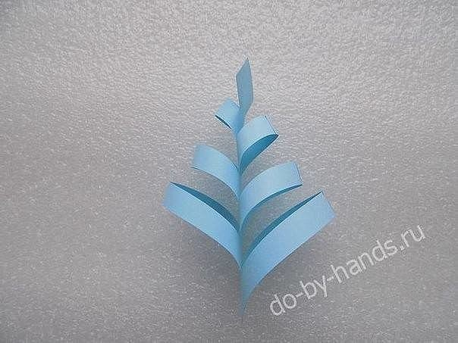](https://ok.ru/dk?cmd=PopLayerPhoto&st.layer.cmd=PopLayerPhotoOuter&st.layer.type=GROUP&st.layer.revNav=off&st.layer.limitedUi=false&st.layer.sphotoIds=849496514051%3B849496514819%3B849496516099%3B849496516355%3B849496517123%3B849496518659%3B849496521731%3B849496522755%3B849496531203&st.layer.showNav=on&st.layer.photoAlbumId=54623410388995&st.layer.epm=off&st.layer.photoId=849496521731&st.layer.opl=off&st.layer.navStartPhotoId=849496521731&st.layer.sbd=off&st.cmd=userMain&st._aid=GroupTopicLayer_openPhotoLayer)

[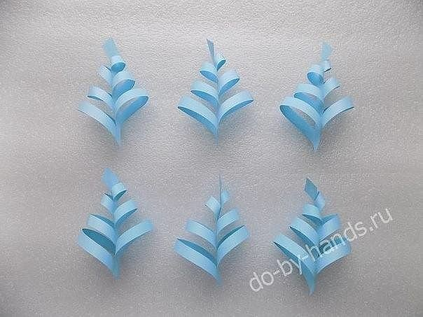](https://ok.ru/dk?cmd=PopLayerPhoto&st.layer.cmd=PopLayerPhotoOuter&st.layer.type=GROUP&st.layer.revNav=off&st.layer.limitedUi=false&st.layer.sphotoIds=849496514051%3B849496514819%3B849496516099%3B849496516355%3B849496517123%3B849496518659%3B849496521731%3B849496522755%3B849496531203&st.layer.showNav=on&st.layer.photoAlbumId=54623410388995&st.layer.epm=off&st.layer.photoId=849496522755&st.layer.opl=off&st.layer.navStartPhotoId=849496522755&st.layer.sbd=off&st.cmd=userMain&st._aid=GroupTopicLayer_openPhotoLayer)

[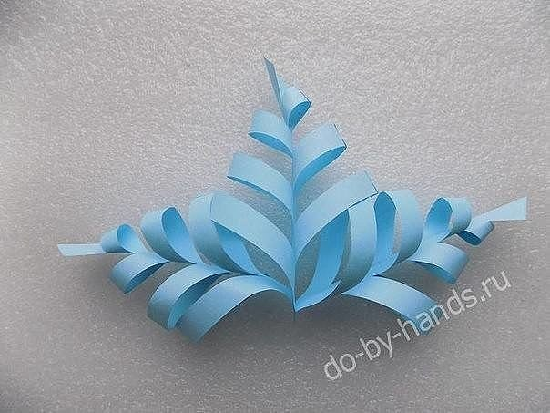](https://ok.ru/dk?cmd=PopLayerPhoto&st.layer.cmd=PopLayerPhotoOuter&st.layer.type=GROUP&st.layer.revNav=off&st.layer.limitedUi=false&st.layer.sphotoIds=849496514051%3B849496514819%3B849496516099%3B849496516355%3B849496517123%3B849496518659%3B849496521731%3B849496522755%3B849496531203&st.layer.showNav=on&st.layer.photoAlbumId=54623410388995&st.layer.epm=off&st.layer.photoId=849496531203&st.layer.opl=off&st.layer.navStartPhotoId=849496531203&st.layer.sbd=off&st.cmd=userMain&st._aid=GroupTopicLayer_openPhotoLayer)